Scrum Masters: Donovan, Yang

**`Sprint 2 Plan - CMPS 115 – Better Quiz App**

Sprint Completion Date: 2/21/2018

Revision 1, 2

High Level Goals: Be able to create a set of quizzes to be taken by the student, Be able to display a question and input an answer from the user, Determine if the quiz answers are right or wrong, Be able to determine a grade out of right and wrong questions.

User story 1: As a frontend developer I want to design a layout for each webpage

* Task 1.1: Set Color Scheme ( 1 hour):
* Task 1.2: Set font ( <1 hour)
* Task 1.3: Map the buttons/ links on each page ( 2 hours)
* Task 1.4: Prepare a dashboard, quiz, and results ( 8 hours)

Total for user story 1: ~12 hours

User story 2: As a user I want to be able to register an account.

* Task 2.1: Create login/signup page (~3 hours)
* Task 2.2: Create a confirmation email (~2 hours)

Total for user story 2: ~5 hours

User story 3: As a backend developer I want to develop a user model.

* Task 3.1: Research about Django and creating users (~4 hours)
* Task 3.2: Add to the User class (~1 hour)

Total for user story 3: ~5 hours

User story 4: As a user I want to see my graded quiz.

* Task 4.1: Save Quiz state to user (~1 hour)
* Task 4.2: Create a user login page and redirect (~3 hours)

Total for user story 4: ~5 hours

User story 5: As a user I want a clear, simple user interface to create quizzes.

* Task 5.1: Implement a navigation bar (~2 hours)
* Task 5.2: Implement a submit button (~1 hour)
* Task 5.3: Implement a back button (~1 hour)
* Task 5.4: Add visual cues for selection choices (~2 hours)

Total for user story 5: ~6 hours

Total hours: ~33 hours

**Team Roles:**

Ethan O’Brien: Product Owner & Backend Dev

Ruben Ayestas: Frontend Dev

Roman Sul: Frontend Dev

Yang Zheng: Scrum Master, Backend Dev

Emmett Greenberg: Backend Dev

Donovan Buccat: Scrum Master, Frontend Dev

**Initial Team Assignment**Whole Team:

Ethan O’Brien: 2.2, 3.1, 4.1

Ruben Ayestas: 1.1, 1.4, 5.2, 5.3

Roman Sul: 1.1, 1.4, 5.4

Yang Zheng: 2.1, 3.2

Emmett Greenberg: 2.2, 3.2, 4.2

Donovan Buccat: 1.3, 1.4, 5.1

**Initial Burnup Chart**

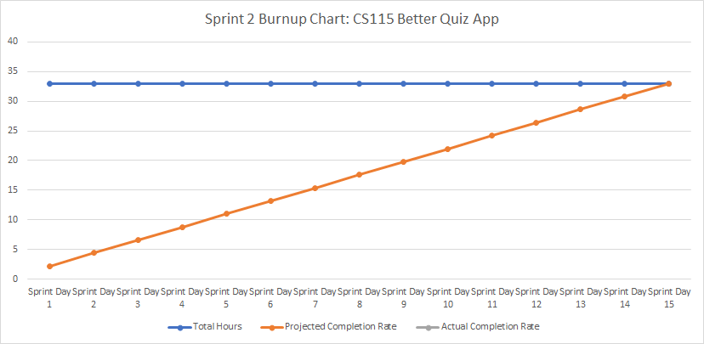

**Scrum Times:**

Monday, Tuesday (with TA), and Friday at 3:30 pm in Baskin 302.